**Dynamic UI Framework**

Contents:

1. Introduction

1.1 About This Document

1.1.1 Scope of this document

1. Component Design

2.1 Component design diagram

2.1.1 Overall Workflow

2.1.2 Low Level Design

1. Technology & Frameworks Used
2. Solution Approach

1. Introduction

1.1 About this document

1.1.1 Scope & Purpose of this document

A Dynamic UI is a user interface that can adapt according to user input. A framework is the basic structure underlying a system. This Dynamic UI Framework will focus on creating a hassle-free interface for the user and will store most of the html data in a JSON format in the client machine in order to reduce time and ultimately, improve user experience.The purpose of this document is to provide a blueprint for developers who want to create a reusable component for a user interface that can be integrated into any application of the same tech stack.

2. Component Design

Component Design Diagram



This is an implementation of a sample template featuring a dynamic UI where the client will interact with the UI while being able to change/view information available by making use of the REST API JSON server.

2.1.1 Overall Workflow



2.1.2 Low level Design

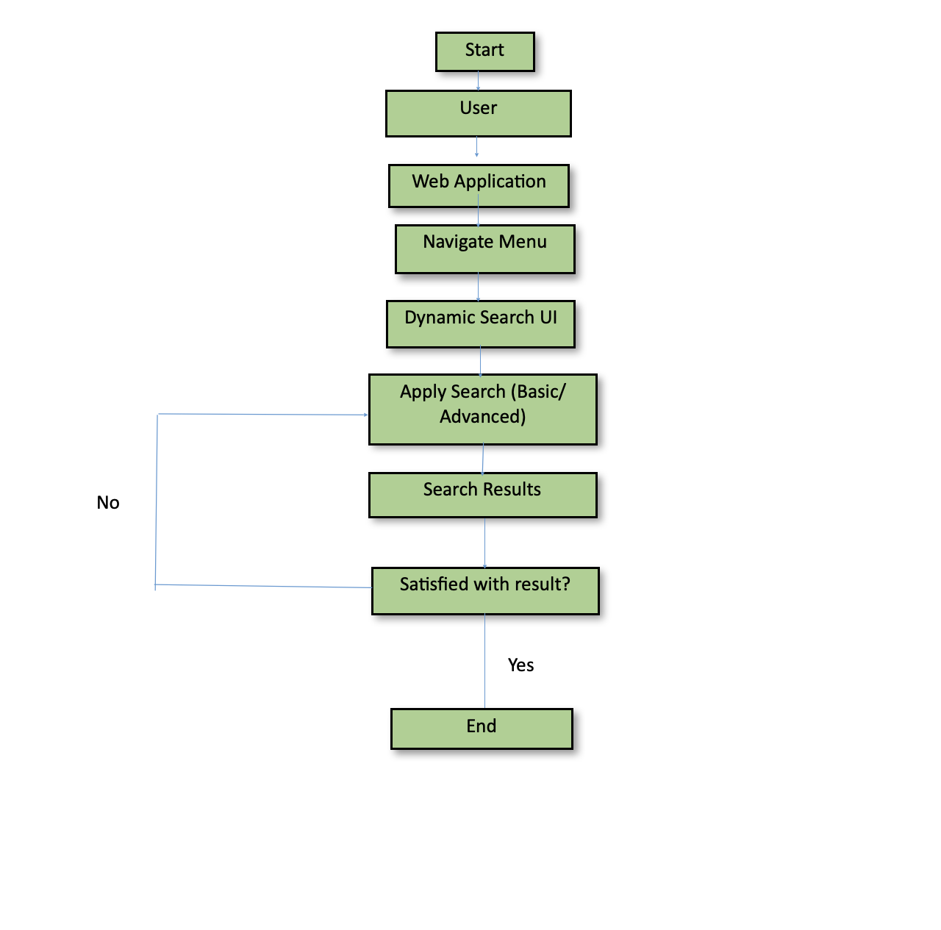

3 Technology & Frameworks used  
This below lists down the details on technology and framework used for development of the UI.

* 1. Angular 15.2.4
  2. Node 19.7.0
  3. Bootstrap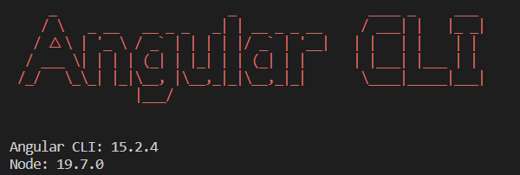

4 Solution Approach

This is a description of how we see clients using our framework.

We have multiple methods that can be reused for many Use-Cases.

These include:

* User Dashboard
  + Creating Data(Stored as JSON)
  + Reading Data
  + Updating Data(Edited JSON)
  + Deleting Data(Removing JSON)
* User Login
  + Dynamic Login Screen
* User Registration/SignUp
  + Dynamic Registration Screen

We use bootstrap’s grid system as it makes it easy to create responsive designs that are easy to adapt to different screen sizes.Bootstrap works seamlessly across different browsers, hence making it our favored platform when designing the front end.We use bootstrap as it allows for responsive images which ensure the images load quickly on all devices.Bootstrap includes pre-built features and code blocks for creating buttons and text boxes which we’ve imported and tweaked according to our needs. Bootstrap is also super lightweight, making it the best choice when designing front end.